Multiple choice section

|  |  |  |  |  |  |  |  |  |  |  |
| --- | --- | --- | --- | --- | --- | --- | --- | --- | --- | --- |
| Question | 1 | 2 | 3 | 4 | 5 | 6 | 7 | 8 | 9 | 10 |
| Answer | A | D | D | B | D | A | D | D | C | C |

Question 1 [8.2]

A

Angles between 180° and 360° are reflex angles.

195° is a reflex angle

Question 2 [8.7]

D

Statements in A, B and C are false.

Question 3 [8.4]

D

⊥ is for perpendicular lines.

Angle between two lines is 90°

Question 4 [8.3]

B

Angles in a revolution add to 360°.

360 – (30 + 180) = 150°

Question 5 [8.7]

D

It is a square, rhombus and a parallelogram.

Question 6 [8.4]

A

|| represents parallel lines

Question 7 [8.5]

D

Question 8 [8.6]

D

It is both equilateral and acute-angled.

Question 9 [8.3]

C

360 – 90 (right angle) = 270°

270 – 20 = 250°

Question 10 [8.3]

C

Vertically opposite angles are equal.

Multiple-choice total marks: 10

Short answer section

Question 11 2 marks [8.2]

Supplementary angles are a pair of angles that sum to 180° (a right angle). e.g. 100° and 80°

Question 12 2 marks [8.1]

(a) 34° (b) 195°

Question 13 2 marks [8.1]

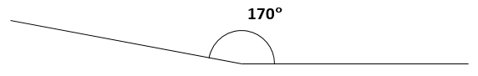

Question 14 4 marks [8.2]

(a) obtuse angles: ∠*VOY* and ∠*VOX*

(b) right angle: ∠*VOW* or ∠*WOZ*

(c) acute angle: any one of ∠*WOX*, ∠*WOY*, ∠*WOP*, ∠*XOY*, ∠*XOP*, ∠*XOZ*, ∠*YOP*, ∠*YOZ*, ∠*POZ*

Question 15 3 marks [8.3]

x + 51 + 129 +142 = 360 (angles in a revolution)

x + 322 = 360

x = 38°

Question 16 1 marks [8.4]

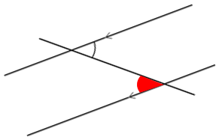

Alternate angle is shaded in red.

Question 17 2 marks [8.4]

x + 47 = 180

x = 133°

(co-interior angles are supplementary)

Question 18 3 marks [8.5]

square, hexagon and a dodecagon

Question 19 4 marks [8.6]

(a)

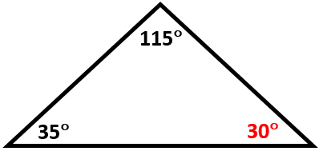  
x + 35 + 115 = 180  
(angle sum in a triangle)  
x + 150 = 180  
x = 30°

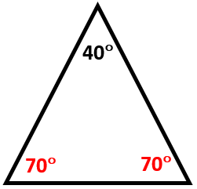  
x + x + 40 = 180  
(angles in an isosceles triangle)  
2x + 40 = 180  
2x = 140  
x = 70°

Question 20 2 marks [8.6]

x = 127 + 23

(exterior angle of a triangle)

x = 150°

Question 21 2 marks [8.7]

x + 83 + 136 + 51 = 360

x + 270 = 360

x = 90°

(angle sum of a quadrilateral)

Question 22 2 marks [8.7]

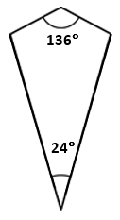

x + x + 136 + 24 = 360

2x + 160 = 360

(angle sum of a quadrilateral)

(opposite angles in a kite are equal)

2x = 200

x = 100°

Question 23 4 marks [8.8]

Draw a line.

Stretch compass a short distance and draw arc with compass needle at one end (right end) of line.

Ensure that arc intersects line.

Without changing spread of compass, draw another arc from intersection point.

Ensure that this second arc intersects with the first arc drawn.

Draw line from original intersection of first arc and line to intersection of arcs.

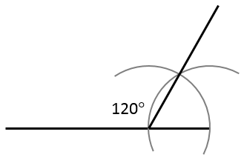

Question 24 4 marks [8.8]

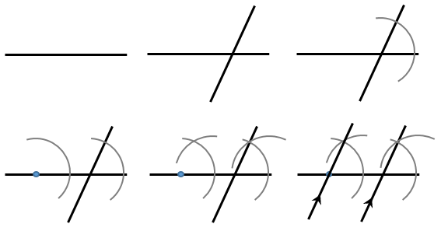

Question 25 5 marks [8.7]

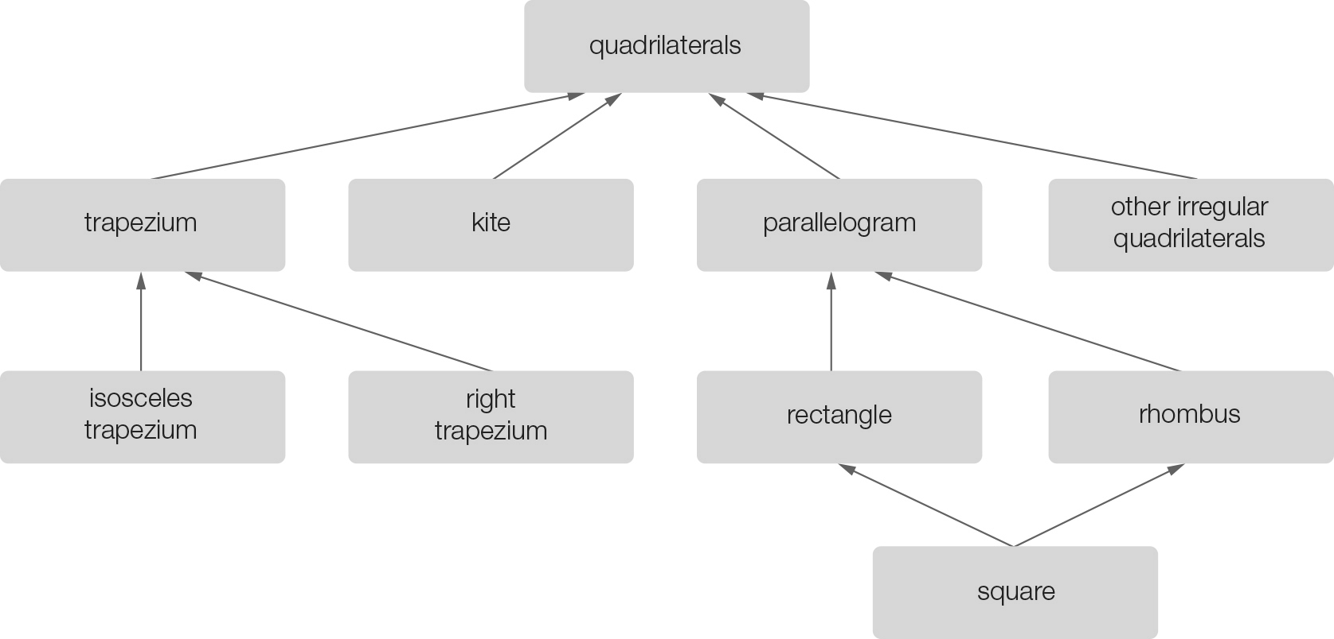 Short answer total: 42

Extended answer section

Question 26 4 marks [8.3]

∠AGC = 23° and ∠EID = 57° (given)

∠HGI = 23°

(vertically opposite angles are equal)

∠GIH = 57°

(vertically opposite angles are equal)

∠HGI + ∠GIH + ∠GHI = 180.

Angle sum of a triangle

23 + 57 + ∠GHI = 180.

∠GHI = 100°

x = 100°

(vertically opposite angles are equal)

Question 27 3 marks [8.3]

10 + 4x = 90

(complementary angles add to 90°)

4x = 80

x = 20°

Question 28 4 marks [8.7]

Internal reflex angle = 360 – 140

Internal reflex angle = 220

(vertically opposite angles are equal)

3y + 3y + 220 + 50 = 360

6y + 270 = 360

6y = 90

y = 15°

Extended answer total: 11

TOTAL test marks: 63